**2.Lift control_up**

**1.Preparation**

1.You need to a Lift version HelloBot.

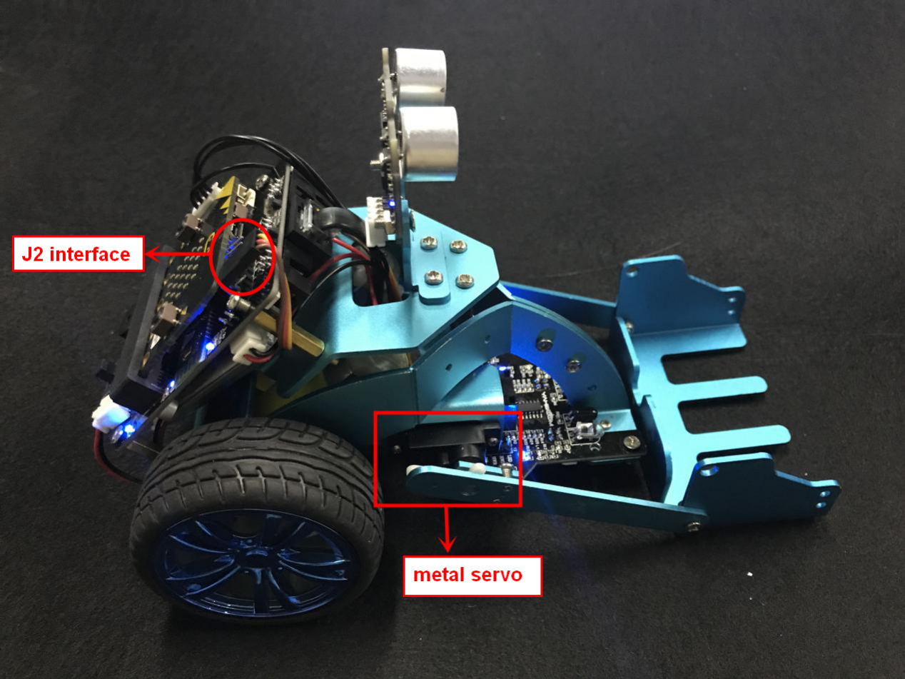

2-1 wiring of metal servo

You need to connect the wiring of the servo to the expansion board, and the servo of the right is connected to the J2 interface. The brown line of the servo corresponds to GND, the red line corresponds to VCC, and the yellow line corresponds to IO.

1. **Learning goals**

In this course, we will learn how to control the robot complete **Forklift control_up,** and learn the angle of the servo when the forklift falls to the ground.

**3.Programming**

3.1 Programming online

**1) You should use the USB cable to connect the micro:bit to the computer, at this point, the computer will have a micro:bit U disk. You need to open it, click micro:bit website, then entered the micro:bit website** or you can enter the URL directly in your browser: http://microbit.org/

2) After entering the programming interface, you need to click Add package and copy the HelloBot package URL: https://github.com/lzty634158/HelloBot to the input field, click to confirm the add package. Then you can use the blocks of the HelloBot package.

3.2 Programming offline

1) You can double-click to use it. As shown in the following figure.

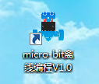

2) After entering the programming interface, you need to click Add package and copy the HelloBot package URL: https://github.com/lzty634158/HelloBot to the input field, click to confirm the add package. Then you can use the blocks of the HelloBot package.

Note: The package only needs to be added once. If you have added packages in the previous lessons, this course does not need to be added repeatedly.

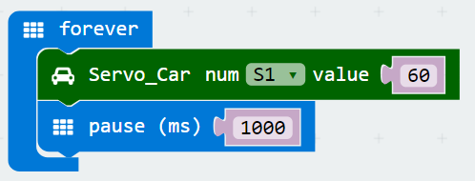

2-2 total program

The locations of blocks in the total program are shown in the following figure.

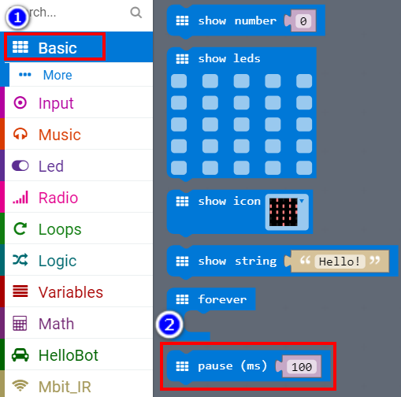

2-3

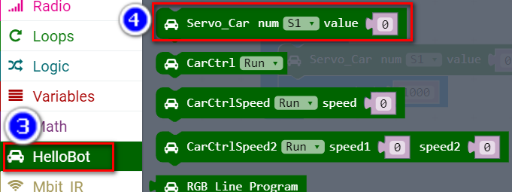

2-4

**4.Download programming**

You need to make sure that the micro:bit development board is connected to the computer. Then you should click on the download in the lower left corner as shown in P 2-5 to download the program to micro:bit.

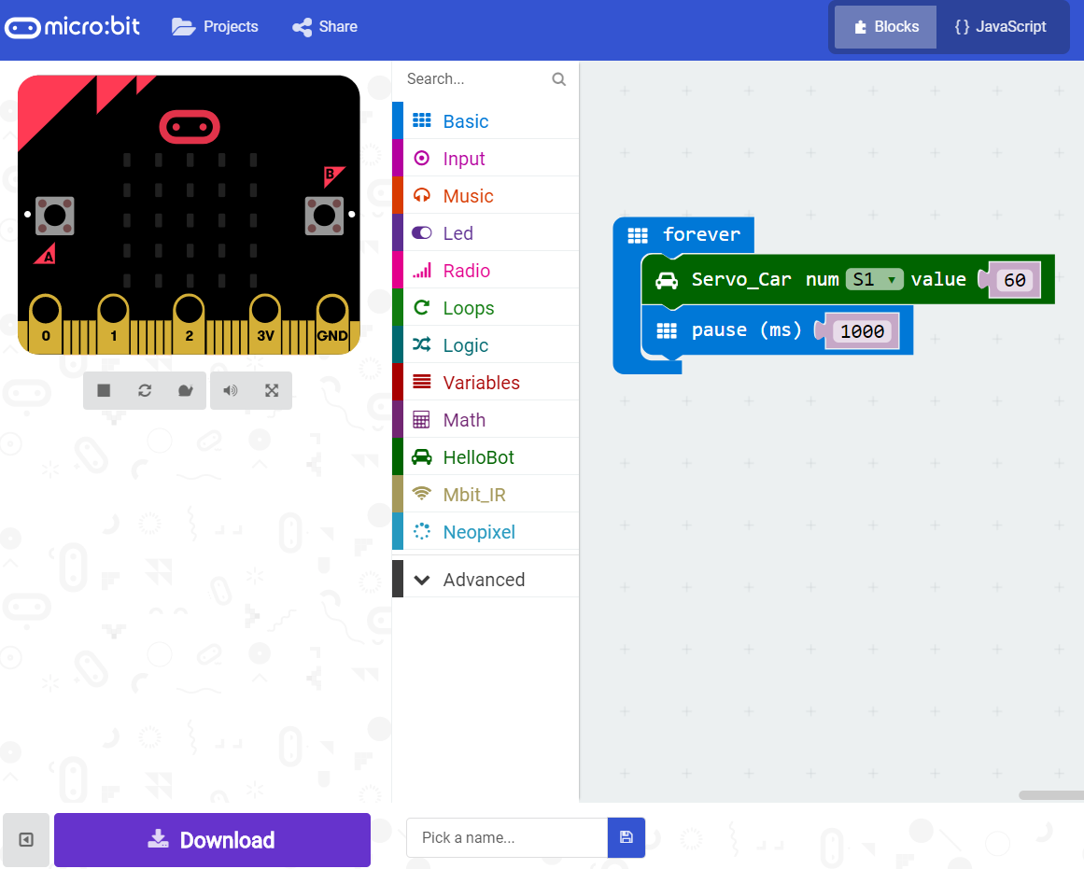

2-5

**5.Phenomenon**

After the code is uploaded. First, we need to put the forklift underneat, as shown in figure 2-6.Then we can start to HelloBot, you can see that the forklift will up, as shown in figure 2-7.

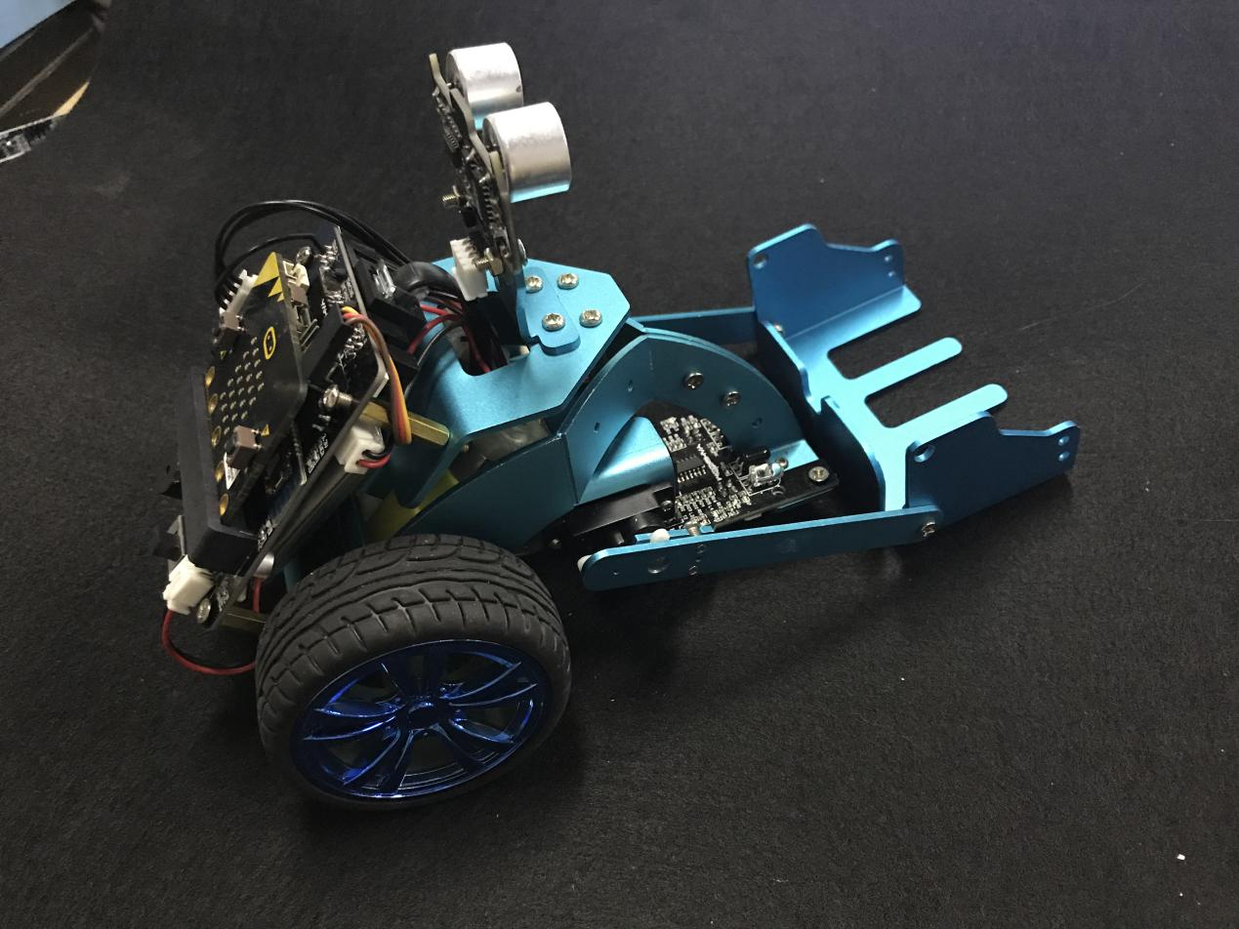

2-6

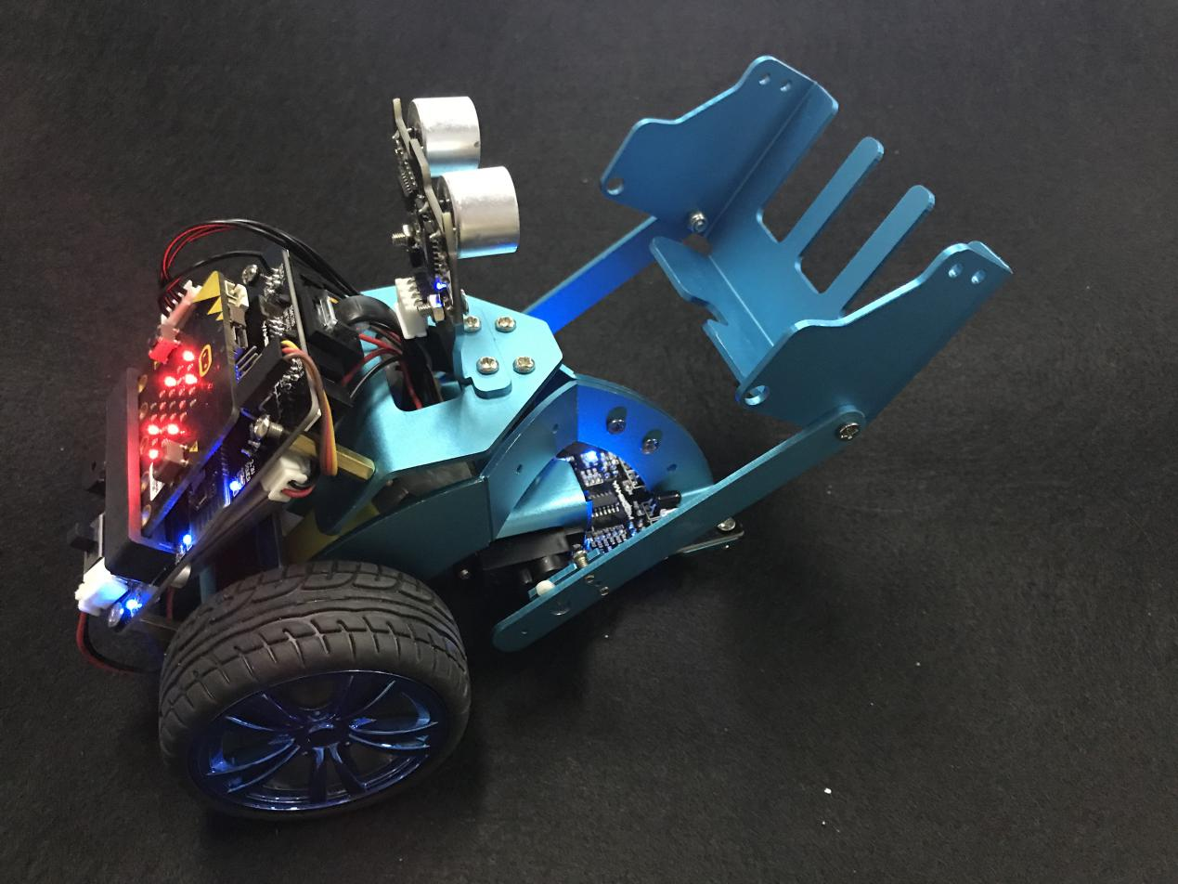

2-7